Kubernetes Task-03
- Create a ClusterIP service for an Apache web server pod.
    - Create Apache Pod YAML
vi apache-pod.yaml
apiVersion: v1
kind: Pod
metadata:
name: apache-pod
labels:
app: apache
spec:
containers:
- name: apache-container
image: httpd
ports:
- containerPort: 80
Apply it:
kubectl apply -f apache-pod.yaml
Verify:
kubectl get pods
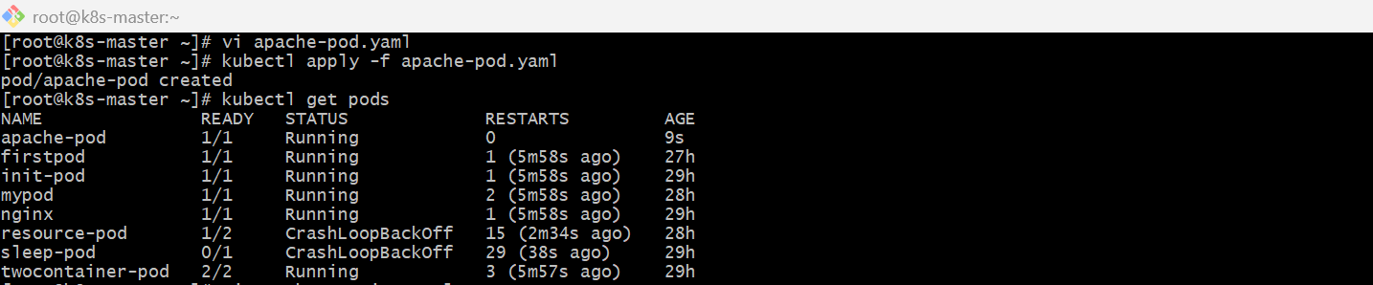
    - Create ClusterIP Service YAML
vi apache-service.yaml
apiVersion: v1
kind: Service
metadata:
name: apache-service
spec:
type: ClusterIP
selector:
app: apache # must match pod label
ports:
- protocol: TCP
port: 80
targetPort: 80
Apply it:
kubectl apply -f apache-service.yaml
    - Verify Service
kubectl get svc
You should see something like:
NAME TYPE CLUSTER-IP PORT(S)
apache-service ClusterIP 10.x.x.x 80/TCP
    - Test the Service
Since ClusterIP is internal, test from inside the cluster:
kubectl run test-pod --image=busybox -it --rm -- sh
Inside pod:
wget -qO- http://apache-service
You should see Apache default HTML page.
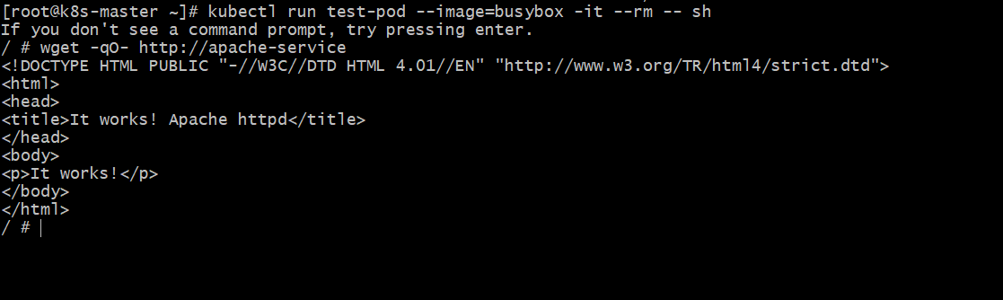
- Expose an Nginx pod externally using a NodePort service.
    - Create Nginx Pod (nginx-pod.yaml)
Vi nginx-pod.yaml
apiVersion: v1
kind: Pod
metadata:
name: nginx-pod
labels:
app: nginx
spec:
containers:
- name: nginx
image: nginx
ports:
- containerPort: 80
Apply it:
kubectl apply -f nginx-pod.yaml
Verify:
kubectl get pods
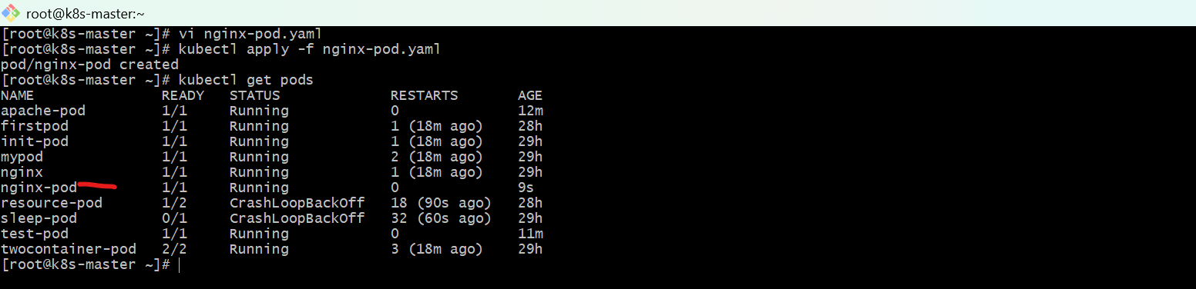
    - Create NodePort Service (nginx-nodeport.yaml)
Vi nginx-nodeport.yaml
apiVersion: v1
kind: Service
metadata:
name: nginx-service
spec:
type: NodePort
selector:
app: nginx
ports:
- protocol: TCP
port: 80 # Service port
targetPort: 80 # Pod port
nodePort: 30007 # External port (range: 30000-32767)
Apply it:
kubectl apply -f nginx-nodeport.yaml
    - Verify Service
kubectl get svc
Example output:
NAME TYPE CLUSTER-IP EXTERNAL-IP PORT(S) AGE
nginx-service NodePort 10.96.12.34 <none> 80:30007/TCP 1m
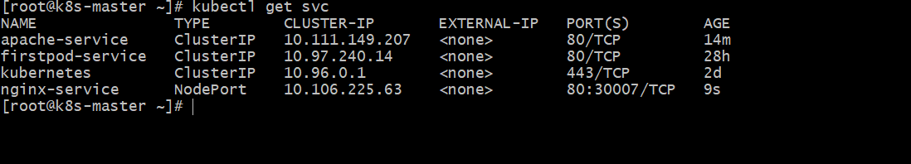
    - Access Nginx in Browser
Use:
http://16.171.151.161:30007
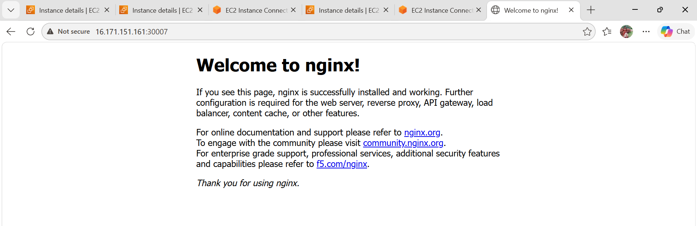
Get Node IP:
kubectl get nodes -o wide
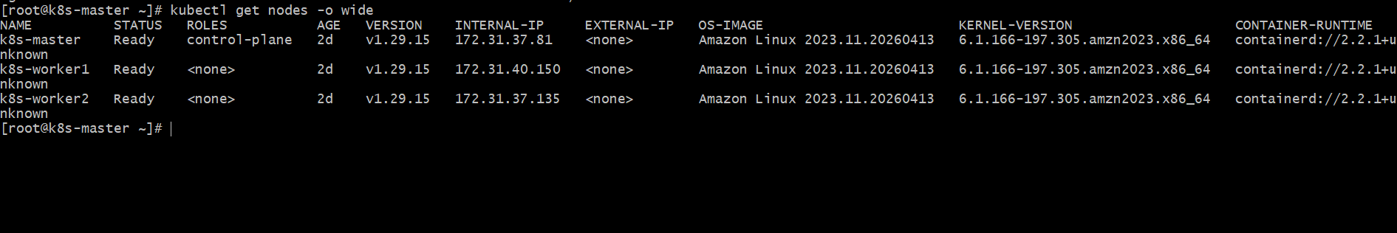
- Deploy a ReplicationController to maintain 3 replicas of an Nginx pod.
    - Create YAML file
Vi nginx-rc.yaml
apiVersion: v1
kind: ReplicationController
metadata:
name: nginx-rc
spec:
replicas: 3
selector:
app: nginx
template:
metadata:
labels:
app: nginx
spec:
containers:
- name: nginx
image: nginx
ports:
- containerPort: 80
    - Deploy the ReplicationController
kubectl apply -f nginx-rc.yaml
    - Verify Pods
kubectl get pods
You should see 3 pods running, like:
nginx-rc-xxxxx Running
nginx-rc-yyyyy Running
nginx-rc-zzzzz Running
    - Verify ReplicationController
kubectl get rc
Output:
NAME DESIRED CURRENT READY
nginx-rc 3 3 3
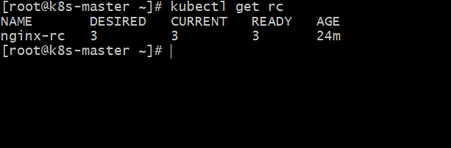
- Scale the ReplicationController from 3 replicas to 5 replicas.
Use this:
kubectl scale rc nginx-rc --replicas=5
Check it:
kubectl get rc
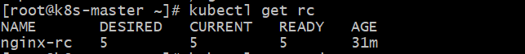
kubectl get pods
You should see desired/current as 5.
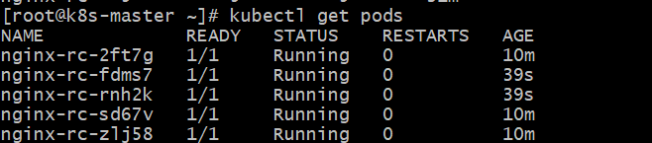
If your ReplicationController name is different, first check:
kubectl get rc
kubectl get rc nginx-rc
It should show something like:
NAME DESIRED CURRENT READY
nginx-rc 5 5 5
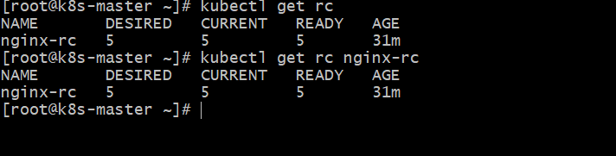

- Create a ReplicaSet to manage pods based on multiple labels (prod and test).
YAML File: replicaset.yaml
Vi replicaset.yaml
apiVersion: apps/v1
kind: ReplicaSet
metadata:
name: nginx-rs-multilabel
spec:
replicas: 3
selector:
matchLabels:
env: prod
type: test
template:
metadata:
labels:
env: prod
type: test
spec:
containers:
- name: nginx
image: nginx
    - Create ReplicaSet
kubectl apply -f replicaset.yaml
    - Check ReplicaSet
kubectl get rs
    - Check Pods with Labels
kubectl get pods --show-labels
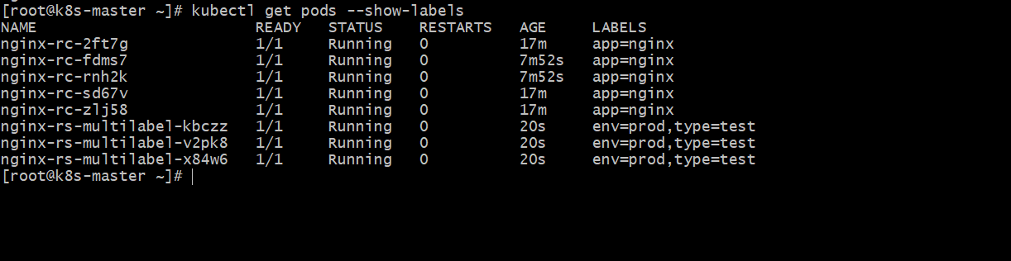
    - Output Example
You should see pods like:
nginx-rs-multilabel-xxxxx Running env=prod,type=test
- Deploy a ReplicaSet that excludes pods with the label backend.
YAML for ReplicaSet (exclude backend pods)
apiVersion: apps/v1
kind: ReplicaSet
metadata:
name: exclude-backend-rs
spec:
replicas: 3
selector:
matchExpressions:
- key: tier
operator: NotIn
values:
- backend
template:
metadata:
labels:
tier: frontend
spec:
containers:
- name: nginx-container
image: nginx
Steps to Deploy
vi exclude-backend-rs.yaml
apiVersion: apps/v1
kind: ReplicaSet
metadata:
name: exclude-backend-rs
spec:
replicas: 3
selector:
matchExpressions:
- key: tier
operator: NotIn
values:
- backend
template:
metadata:
labels:
tier: frontend
spec:
containers:
- name: nginx-container
image: nginx
Paste YAML → save
kubectl apply -f exclude-backend-rs.yaml
Verify
kubectl get rs
kubectl get pods --show-labels
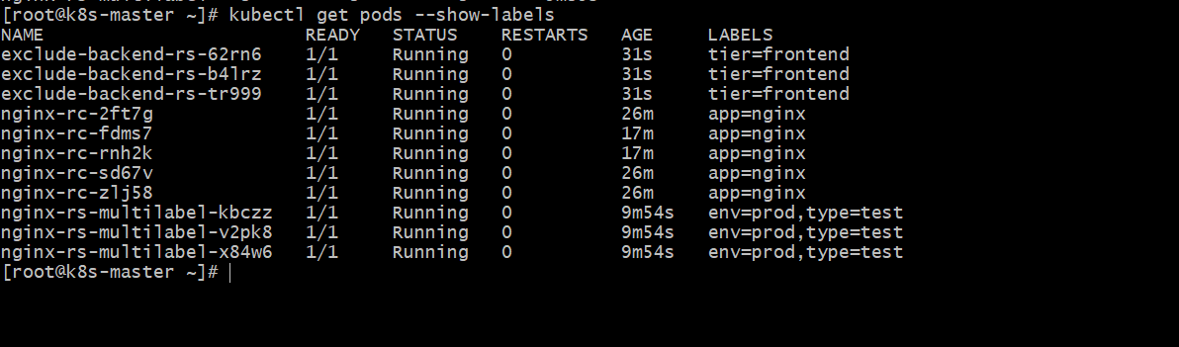

- Test load balancing across multiple pods using a NodePort service.
    - Create a Deployment with 3 nginx pods
Vi lb-deploy.yaml
Save as lb-deploy.yaml
apiVersion: apps/v1
kind: Deployment
metadata:
name: nginx-lb
spec:
replicas: 3
selector:
matchLabels:
app: nginx-lb
template:
metadata:
labels:
app: nginx-lb
spec:
containers:
- name: nginx
image: nginx
ports:
- containerPort: 80
Apply it:
kubectl apply -f lb-deploy.yaml
kubectl get pods -o wide
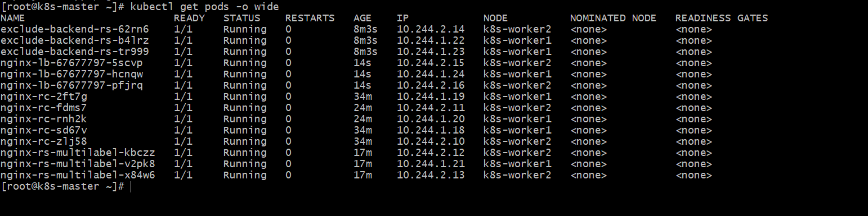
    - Expose it using NodePort service
Vi lb-nodeport.yaml
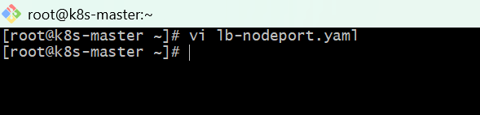
Save as lb-nodeport.yaml
apiVersion: v1
kind: Service
metadata:
name: nginx-lb-service
spec:
type: NodePort
selector:
app: nginx-lb
ports:
- port: 80
targetPort: 80
nodePort: 30080
Apply it:
kubectl apply -f lb-nodeport.yaml

kubectl get svc
You should see something like:
NAME TYPE CLUSTER-IP EXTERNAL-IP PORT(S) AGE
nginx-lb-service NodePort 10.x.x.x <none> 80:30080/TCP 10s
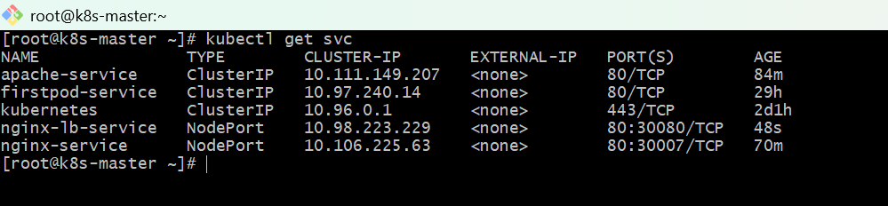

    - Get node IP
Run:
kubectl get nodes -o wide
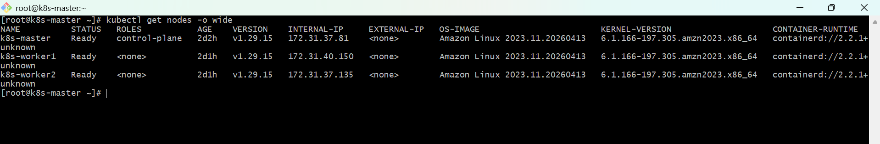
Take the Internal-IP or server IP of your worker/master node.
Example:
16.171.151.161
Test the service from browser or curl
Run this many times:
curl http:// 16.171.151.161:30080
Since all nginx pods return same page, load balancing is happening but you cannot clearly see which pod answered.
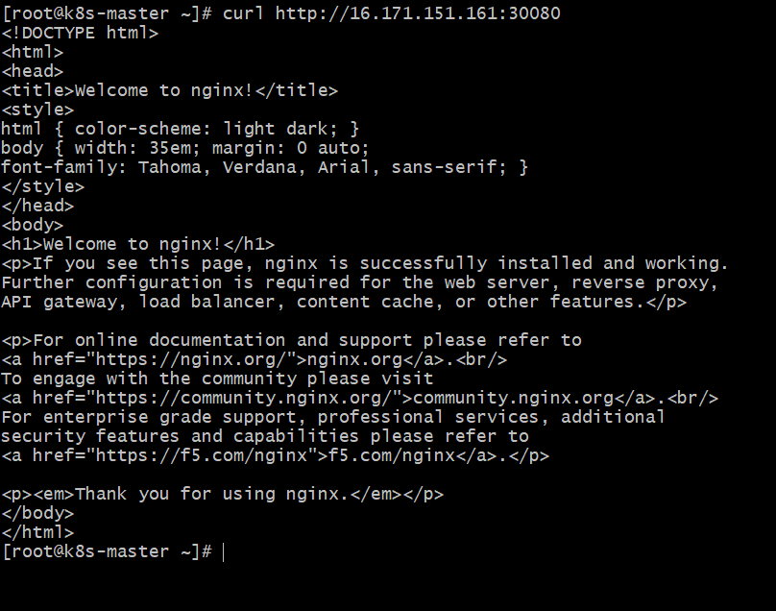

    - To clearly verify load balancing, create pods with pod hostname in output
Use this better Deployment instead.
Save as lb-test.yaml
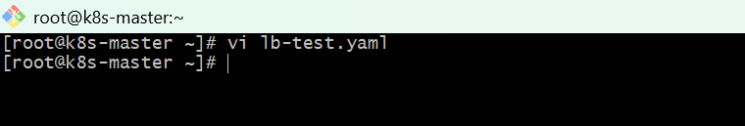
apiVersion: apps/v1
kind: Deployment
metadata:
name: hostname-app
spec:
replicas: 3
selector:
matchLabels:
app: hostname-app
template:
metadata:
labels:
app: hostname-app
spec:
containers:
- name: web
image: nginx
ports:
- containerPort: 80
command: ["/bin/sh", "-c"]
args:
- 'echo "Pod Name: $(hostname)" > /usr/share/nginx/html/index.html && nginx -g "daemon off;"'
Apply it:
kubectl apply -f lb-test.yaml

Now create NodePort service:
Save as hostname-nodeport.yaml
apiVersion: v1
kind: Service
metadata:
name: hostname-service
spec:
type: NodePort
selector:
app: hostname-app
ports:
- port: 80
targetPort: 80
nodePort: 30081
Apply:
kubectl apply -f hostname-nodeport.yaml
kubectl get pods
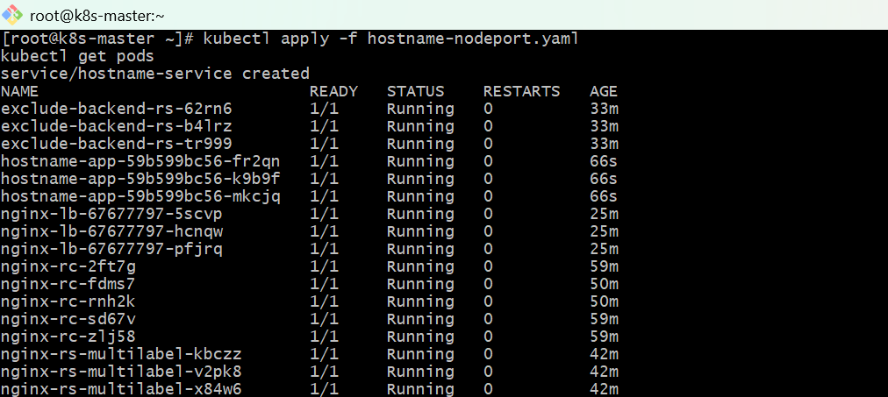

kubectl get svc
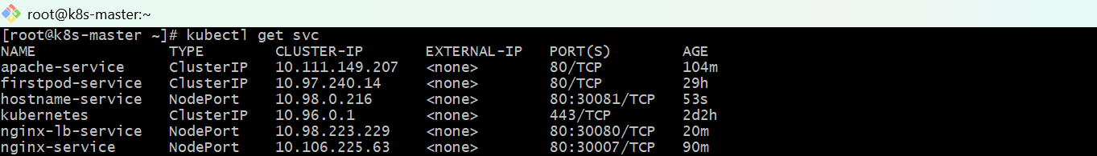
    - Verify load balancing
Run curl multiple times:
curl http://<NodeIP>:30081
curl http://<NodeIP>:30081
curl http://<NodeIP>:30081
curl http://<NodeIP>:30081
Output will change like:
Pod Name: hostname-app-7d9c8b6d9f-abc12
Pod Name: hostname-app-7d9c8b6d9f-xk291
Pod Name: hostname-app-7d9c8b6d9f-pq456
That proves the NodePort service is load balancing traffic across multiple pods.
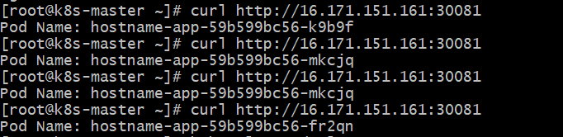
- Delete a ReplicationController without affecting the running pods.
To check the ReplicationController (RC) name, use this command:
kubectl get rc
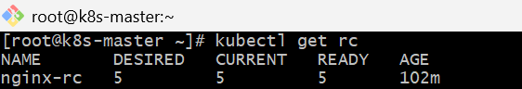
Use this command:
kubectl delete rc <rc-name> --cascade=orphan
Example:
kubectl delete rc nginx-rc --cascade=orphan
What it does:
- Deletes the ReplicationController
- Keeps the running Pods alive
Check before and after:
kubectl get rc
kubectl get pods
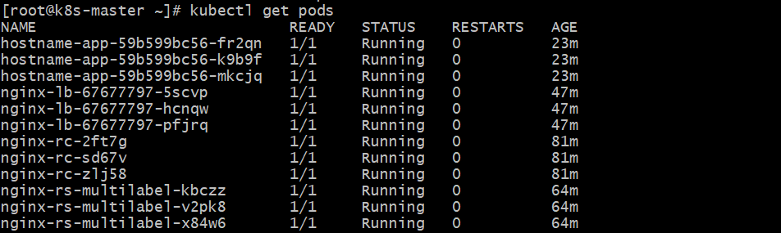
You will see:
- RC is deleted
- Pods are still running
kubectl get pods -o wide
